Bethel Lutheran Church
Maundy Thursday Agape Meal, April 17, 2025
Rev. Molly Wills, Pastor and Jan Smith, Accompanist

Gathering
(The congregation’s responses are in bold letters.)
GREETING The Lord be with you.
And also with you.
SONG Three Holy Days Enfold Us Now

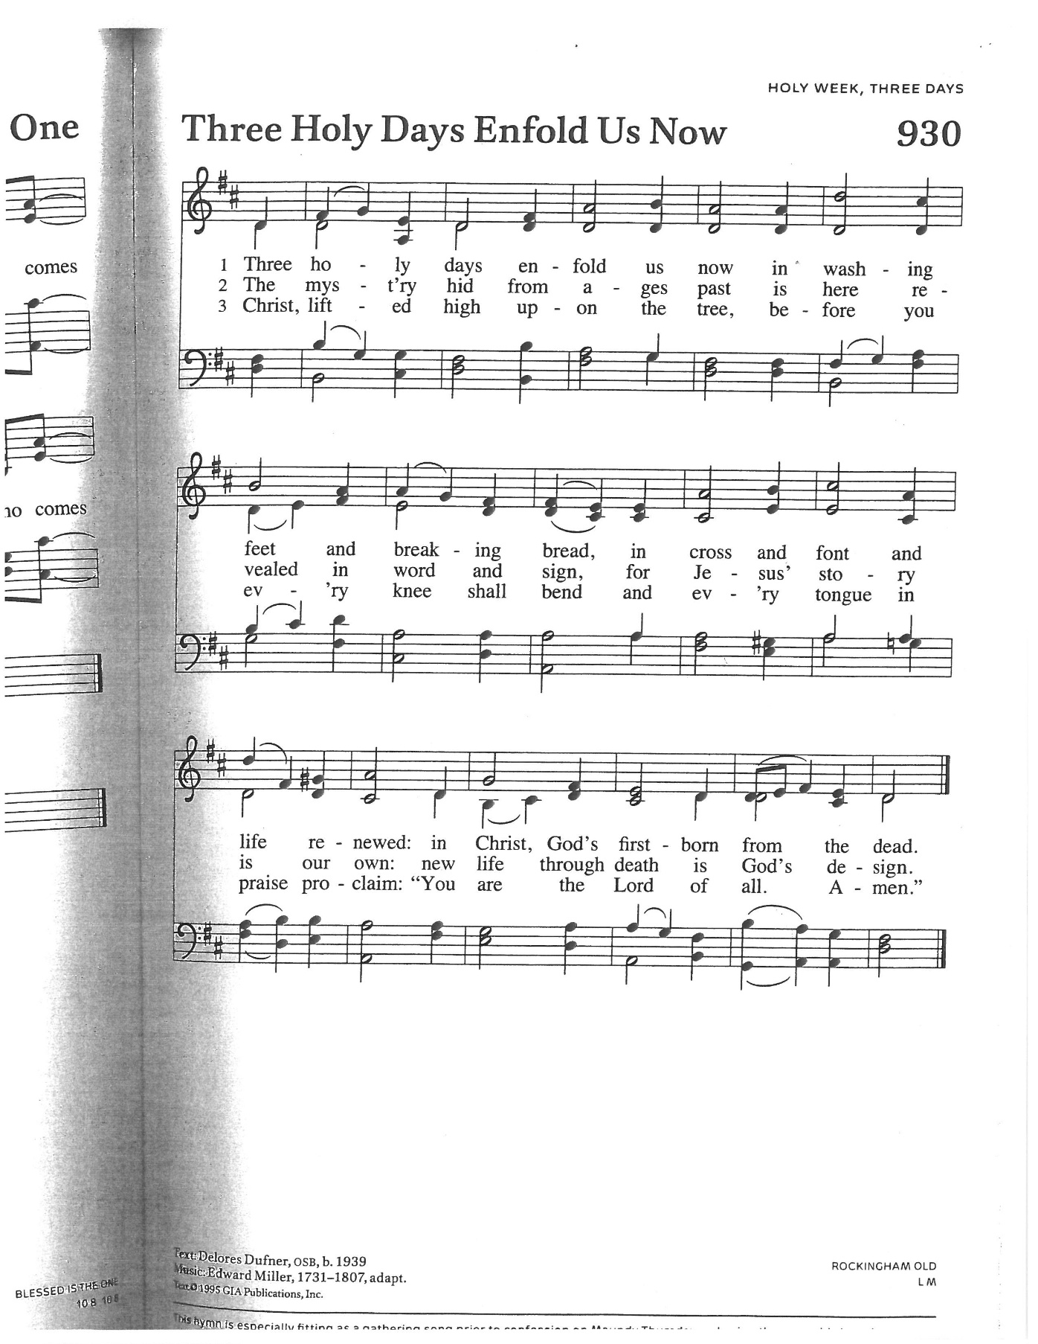

A READING FROM JOHN 13:1-17
¹ Now before the festival of the Passover, Jesus knew that his hour had come to depart from this world and go to the Father. Having loved his own who were in the world, he loved them to the end. ² The devil had already decided^{[a]} that Judas son of Simon Iscariot would betray Jesus. And during supper ³ Jesus, knowing that the Father had given all things into his hands and that he had come from God and was going to God, ⁴ got up from supper, took off his outer robe, and tied a towel around himself. ⁵ Then he poured water into a basin and began to wash the disciples’ feet and to wipe them with the towel that was tied around him. ⁶ He came to Simon Peter, who said to him, “Lord, are you going to wash my feet?” ⁷ Jesus answered, “You do not know now what I am doing, but later you will understand.” ⁸ Peter said to him, “You will never wash my feet.” Jesus answered, “Unless I wash you, you have no share with me.” ⁹ Simon Peter said to him, “Lord, not my feet only but also my hands and my head!” ¹⁰ Jesus said to him, “One who has bathed does not need to wash, except for the feet,^{[b]} but is entirely clean. And you^{[c]} are clean, though not all of you.” ¹¹ For he knew who was to betray him; for this reason he said, “Not all of you are clean.”
¹² After he had washed their feet, had put on his robe, and had reclined again, he said to them, “Do you know what I have done to you? ¹³ You call me Teacher and Lord, and you are right, for that is what I am. ¹⁴ So if I, your Lord and Teacher, have washed your feet, you also ought to wash one another’s feet. ¹⁵ For I have set you an example, that you also should do as I have done to you. ¹⁶ Very truly, I tell you, slaves are not greater than their master, nor are messengers^{[d]} greater than the one who sent them. ¹⁷ If you know these things, you are blessed if you do them.
Hear what the Spirit is saying to God’s people.
Thanks be to God.
Fellow servants of our Lord Jesus Christ, on the night before his death, Jesus set an example for his disciples by washing their feet, an act of humble service. He taught that strength and growth in the life of the kingdom of God come not by power, authority, or even miracle, but by such lowly service. You share in the royal priesthood of Christ, and before you entered here you were invited to follow the example of our Master, in whose ministry we share. For “a servant is not greater than his master, nor are those who are sent greater than the one who sent them.”
Peace is my last gift to you, my own peace I now leave with you; peace which the world cannot give, I give to you.
I give you a new commandment: Love one another as I have loved you.
Peace is my last gift to you, my own peace I now leave with you; peace which the world cannot give, I give to you.
By this shall the world know that you are my disciples: That you have love for one another.
All Peace is my last gift to you, my own peace I now leave with you; peace which the world cannot give, I give to you.
Holy God, source of all love, on the night of his betrayal Jesus gave his disciples a new commandment, to love one another as he loved them. Write this commandment in our hearts; give us the will to serve others as he was the servant of all, who gave his life and died for us, yet is alive and reigns with you and the Holy Spirit, one God, now and forever.
Amen.
This is the day that Christ the Lamb of God gave himself into the hands of those who would slay him. This is the day that Christ gathered with his disciples in the upper room. This is the day that Christ took a towel and washed the disciples’ feet, giving us an example that we should do to others as he has done to us. This is the day that Christ our God gave us the holy feast, that we who eat the bread and drink the cup may remember his holy sacrifice and be partakers of his resurrection, and at the last day may reign with him in heaven.
All Lord have mercy. Christ have mercy. Lord have mercy.
Father, we spread this table to remember the loving sacrifice of Jesus Christ, your Son. Accept all we offer you this day. Bind us together in his love and in the love he has commanded us to bring one another; through Jesus Christ our Lord.
Amen.
SONG Great God Your Love Has Called Us (see insert)
Blessing Over the Bread
Blessed are you, O Lord our God, King of the universe, who has given us bread from the earth. On the night that Jesus gathered with his friends, he took bread and blessed it and shared it with his friends, for God who loves us, feeds us. As God’s people ate manna in the wilderness and were satisfied, so we share this bread with Christ, and with one another. May it be for us bread from heaven, strength for our bodies, and balm for our souls, and may it empower us to be Christ’s body in this world.
(The bread is passed around the table, each receiving a piece. After this, the meal begins.)
A READING FROM EXODUS 12:1-14
The LORD said to Moses and Aaron in the land of Egypt: This month shall mark for you the beginning of months; it shall be the first month of the year for you. Tell the whole congregation of Israel that on the tenth of this month they are to take a lamb for each family, a lamb for each household. If a household is too small for a whole lamb, it shall join its closest neighbor in obtaining one; the lamb shall be divided in proportion to the number of people who eat of it. Your lamb shall be without blemish, a year-old male; you may take it from the sheep or from the goats. You shall keep it until the fourteenth day of this month; then the whole assembled congregation of Israel shall slaughter it at twilight. They shall take some of the blood and put it on the two doorposts and the lintel of the houses in which they eat it. They shall eat the lamb that same night; they shall eat it roasted over the fire with unleavened bread and bitter herbs. Do not eat any of it raw or boiled in water, but roasted over the fire, with its head, legs, and inner organs. You shall let none of it remain until the morning; anything that remains until the morning you shall burn. This is how you shall eat it: your loins girded, your sandals on your feet, and your staff in your hand; and you shall eat it hurriedly. It is the passover of the LORD. For I will pass through the land of Egypt that night, and I will strike down every firstborn in the land of Egypt, both human beings and animals; on all the gods of Egypt I will execute judgements: I am the LORD. The blood shall be a sign for you on the houses where you live: when I see the blood, I will pass over you, and no plague shall destroy you when I strike the land of Egypt. This day shall be a day of remembrance for you. You shall celebrate it as a festival to the LORD; throughout your generations you shall observe it as a perpetual ordinance.
Hear what the Spirit is saying to God’s people.
Thanks be to God. (The meal continues.)
A READING FROM PSALM 78:14-25 (Read responsively)
14 In the daytime he led them with a cloud and all night long with a fiery light.
15 He split rocks open in the wilderness and gave them drink abundantly as from the deep.
16 He made streams come out of the rock and caused waters to flow down like rivers.
17 Yet they sinned still more against him, rebelling against the Most High in the desert.
18 They tested God in their heart by demanding the food they craved.
19 They spoke against God, saying, “Can God spread a table in the wilderness?
20 Even though he struck the rock so that water gushed out and torrents overflowed, can he also give bread or provide meat for his people?”
21 Therefore, when the Lord heard, he was full of rage; a fire was kindled against Jacob, his anger mounted against Israel,
22 because they had no faith in God and did not trust his saving power.
23 Yet he commanded the skies above and opened the doors of heaven;
24 he rained down on them manna to eat and gave them the grain of heaven.
25 Mortals ate the bread of angels; he sent them food in abundance.
Hear what the Spirit is saying to God’s people.
Thanks be to God. (The meal continues.)
A READING FROM 1 CORINTHIANS 11:23-26
For I received from the Lord what I also handed on to you, that the Lord Jesus on the night when he was betrayed took a loaf of bread, ²⁴ and when he had given thanks, he broke it and said, “This is my body that is for you. Do this in remembrance of me.” ²⁵ In the same way he took the cup also, after supper, saying, “This cup is the new covenant in my blood. Do this, as often as you drink it, in remembrance of me.” ²⁶ For as often as you eat this bread and drink the cup, you proclaim the Lord’s death until he comes.
Hear what the Spirit is saying to God’s people.
Thanks be to God. (The meal continues.)
Blessing Over the Wine
Let us pray. Blessed are you, O Lord our God, Ruler of the universe, who gives us wine, the fruit of the vine and work of human hands. On the night that Jesus gathered with his friends he took wine, and he blessed it and shared it with them. May this [wine] be for us the holy drink of heaven, and may it wash us of sin and quench the thirst of our souls. Amen.
(Everyone receives wine in a cup and drinks it together.)
SONG What Feast of Love, verses 1,3,4 (see insert)
CLOSING PRAYER
Holy God, source of grace abounding and steadfast love, on this day you gave yourself into the hands of those who would slay you. On this day, you gathered with your disciples in the upper room. On this day you took a towel and washed your disciples’ feet, giving us an example that we should do to others as you have done to us. On this day you gave us a new commandment, to love one another as you have loved us. And on this day you gave us the holy feast, that we who eat the bread and drink the cup may remember your holy sacrifice and be partakers of your resurrection, and at the last day may reign with you in heaven. Write your commandment on our hearts, stir up within us the will to love and serve others. In the name of the Father, Son, and Holy Spirit, one God, now and forever.
Amen.
Stripping the Tables
(In silence, the tables are completely cleared, and everyone leaves quietly.)
(Please leave an offering in the plate as you exit, or text the dollar amount to 866-298-7547 or scan the QR code.)

From sundaysandseasons.com.Copyright © 2025 Augsburg Fortress. All rights reserved.
Compiled using resources from the Book of Alternative Services; from the 1979 Book of Common Prayer of The Episcopal
Church (USA); Goertner, Coeur d’Alene, Idaho; and from the work of the Rev’d Josephine Robinson, Bellevue, Washington.

